Technical Report

Embedded System Project: Advanced PC FAN speed controller with over speed alarm.

Author: Martins Osemudiamen Okoh.

TU Dublin ID: A0004717

Table of Content

- AIm 1
- Objective 1
- Design 1
- Components 2
- Software Code 9
- Testing 20
- Conlusion 24
- Reference 25

Table of Table

- Table 1: STM32L432KC 2
- Table 2: PIN connection 2
- Table 3: Button 3
- Table 4: LED 3
- Table 5: Resistor 3
- Table 6: Rotary Encoder 4
- Table 7: PIN connection 4
- Table 8: LCD Screen 5
- Table 9: PIN connection 5
- Table 10: Buzzer 5
- Table 11: PC FAN 6
- Table 12: 4-wire PinOut 6
- Table 13: USB Cable 7
- Table 14: Breadboard 7
- Table 15: Connecting wires 7
- Table 16: Power Supply 8

Tables of Figures
- Figure 1: Ciricuit Design of PC fan controller using KICad 10.0. 1
- Figure 2: Declaration of functions and addition of necessary files and libraries. 9
- Figure 3: Declaration of global variables. 9
- Figure 4: Main function of the software implementation part 1. 10
- Figure 5: Main function of the software implementation part 2. 11
- Figure 6: Main function of the software implementation part 3. 11
- Figure 7: Main function of the software implementation part 4. 12
- Figure 8: Setup Function. 13
- Figure 9: delay , Pull Up resistor and Pinmode. 14
- Figure 10: Timer 2. 15
- Figure 11: Timer 16. 16
- Figure 12: Timer 6. 16
- Figure 13: Timer 6 interrupt . 17
- Figure 14: Function of installing delay. 17
- Figure 15: Function to enable pull-up resistor. 17
- Figure 16: Function for PIN mode selection. 18
- Figure 17: Function for initializing clock. 18
- Figure 18: Function of initializing serial communication and pin definition. 18
- Figure 19: Function for writing via serial communication. 19
- Figure 20: Function for write via serial communication to terminal display. 19
- Figure 21: Function to handle interrupt to counting the speed pulse. 19
- Figure 22: Function for milliseconds counting and delays. 19
- Figure 23: Hardware implementation of bread board. 20
- Figure 24: Power supply. 21
- Figure 25: Output result 1 on terminal. 21
- Figure 26: Output result 2 on terminal. 21
- Figure 27: Fan output speed signal 1 viewed on oscilloscope. 22
- Figure 28: PC fan Assemble with LED ON and Screen. 22
- Figure 29: Output result 2 on terminal. 23
- Figure 30: Fan output speed signal 2 viewed on oscilloscope. 23
- Figure 31: PC fan Assemble with LED OFF, Buzzer toggling and Screen . 24
Aim: Design and implementation of a Advanced PC fan speed controller using STM32L432KC microcontroller with overspeed alarm.

Objective:
- Schematic design of the PC fan speed controller.
- Software implementation.
- Hardware implementation.
- Testing / Debugging.
- Documentation.

Design:

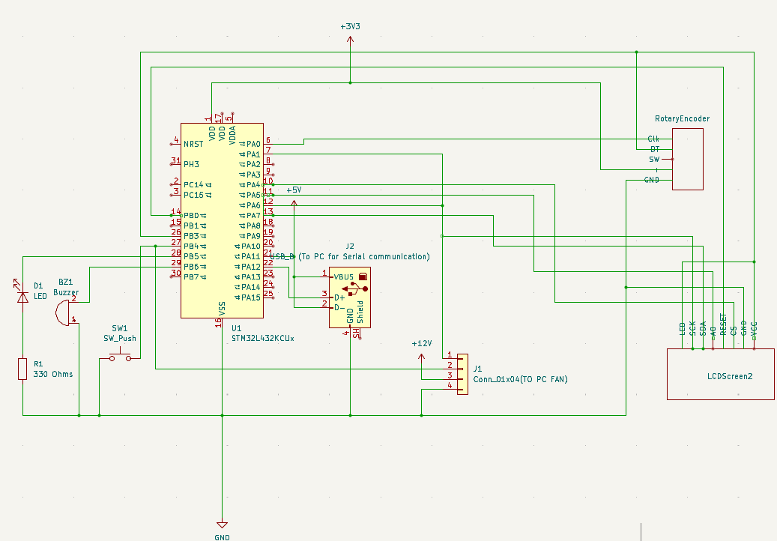
Figure 1: Ciricuit Design of PC fan controller using KICad 10.0.

In the Figure 1 above, the design comprises of STM32L432KC microcontroller, a push button, an LED,330 Ohms resistor, Rotary Encoder, LCD Screen, Buzzer, PC fan 4 wire connector, a USB cable component for serial communication, voltage supplies of 3.3 and 12 voltages, connecting wires, breadboard and a ground.

Components:

- STM32L432KC Microcontroller:

Table 1: STM32L432KC
Specification | Detail
Manufacturer | STMicroelectronics
Core | ARM Cortex-M4F (with FPU)
Max frequency | 80 MHz
Flash memory | 256 KB
SRAM | 64 KB
Operating voltage | 1.71V – 3.6V
Package | 32-pin QFN
Key peripherals | GPIO, TIM2, TIM6, TIM16, USART, SPI, EXTI, NVIC

Component Role: Central processing unit. Runs the main control loop, reads encoder and push button inputs, generates PWM for the fan, controls the LED and buzzer, communicates with the LCD via SPI, and outputs debug data over USB serial. It also serve as a 3.3 volt power supply for the circuit [1).

Connection: The Pin connection is as in Table 2.
Table 2: PIN connection
Pin | Direction | Function
PA0 | Input | TIM2_CH1 – Encoder CLK (AF1)
PA2 | Output | USART2_TX – Serial transmit (AF7)
PA5 | Output | SPI1_SCK – Display clock
PA6 | Output | TIM16_CH1 – PWM fan control (AF14)
PA7 | Output | SPI1_MOSI – Display data
PA15 | Input | USART2_RX – Serial receive (AF3)
PB3 | Input | TIM2_CH2 – Encoder DT (AF1)
PB4 | Input | EXTI4 – Tachometer pulse input (falling edge)
PB5 | Output | GPIO – LED overspeed indicator
PB6 | Output | GPIO – Buzzer tone output (toggled by TIM6)

All peripherals are clocked through the internal PLL configured to 80 MHz at startup in initClocks(). SysTick is configured to interrupt every 1 ms to provide the delay_ms() timebase [2].

- Push Down Button:
Table 3: Button
Specification | Detail
Type | Tactile momentary switch
Number of pins | 2 connected internally
Actuation Force | 100 - 300gf
Contact resistance | < 100 mΩ
Operating life | 10,000 – 100,000 cycles

Component Role: Provides user input for controlling the system (e.g., starting/stopping the fan, resetting the system, or toggling display modes). In this project, it may serve as the tachometer pulse input or a manual override switch [3].

Connection: Connected to PB4 with internal pull-up enabled. When pressed, the pin reads LOW (0V); when released, pull-up keeps it HIGH (3.3V). Falling edge triggers an external interrupt.

- Light Emitting Diode (LED) :
Table 4: LED
Specification | Detail
Type | Standard 5mm or SMD LED
Color | Green
Forward voltage (Vf) | 2.8V – 3.2V (green)
Forward current (If) | 10 – 20 mA
Viewing angle | 30° – 60°
Luminous intensity | 1000 – 5000 mcd

Component Role: Visual status indicator. Illuminates when the fan speed is within safe limits (≤ 3500 RPM) and turns off during over speed conditions [4].
Connection: Anode connected to PB5 through a 330Ω current-limiting resistor; cathode connected to ground.
- 330 Ohm resistor:
Table 5: Resistor
Specification | Detail
Resistance | 330 Ω ±5%
Power rating | 0.25W (1/4W)
Type | Carbon film or metal film
Color code | Orange – Orange – Brown – Gold

Component Role: Current-limiting resistor for the LED. 330Ω provides approximately 4 mA current, ensuring safe operation without exceeding the LED's maximum rating or the microcontroller's GPIO current limit (20 mA per pin) [5].
Connection: Placed in series between PB5 (microcontroller output) and the LED anode.
- Rotary Encoder:

Table 6: Rotary Encoder
Specification | Detail
Type | Incremental quadrature encoder
Pulses per revolution (PPR) | 2 (as defined in code: #define pulse_per_rev 2)
Output signals | Channel A (CLK), Channel B (DT)
Output type | Open-collector or push-pull
Supply voltage | 3.3V – 5V
Mechanical life | 30,000 – 100,000 cycles
Encoder Count Range | 0 – 159 (set by TIM2 ARR = 159 in code)

Component Role: Provides the primary user input for fan speed control. As the knob is rotated clockwise or counter-clockwise, it generates two out-of-phase square wave signals (CLK and DT) which TIM2 decodes in hardware encoder mode 3 (quadrature). The resulting count value in TIM2->CNT (ranging 0–159) is read in the main loop and scaled to a PWM duty cycle on TIM16, directly controlling fan speed. Rotating fully clockwise produces maximum PWM (100% duty), and fully counter-clockwise produces minimum (0%) [6].
Connection: The Pin connection is as in Table 2.
Table 7: PIN connection
Encoder Pin | STM32L432 Pin
CLK | PA0
DT | PB3
VCC | 3.3v
GND | GND
SW | -

How it works: PA0 and PB3 are configured in alternate function mode (AF1) to route directly into TIM2's hardware encoder interface. TIM2 is configured in encoder mode 3 (TIM2->SMCR = 3), meaning both edges of both channels are counted, giving smooth and accurate position tracking. The counter wraps between 0 and 159 as set by TIM2->ARR = 159. No software debouncing is required as the hardware timer filters signal noise inherently. Internal pull-ups are not explicitly set for PA0/PB3 as the encoder module typically includes its own pull-up resistors on CLK and DT.

- LCD Screen (SPI Interface)

Table 8: LCD Screen
Specification | Detail
Type | 1.8" TFT SPI LCD v1.1
Resolution | 128 × 160 pixels
Display Driver IC | ST7735S
Interface | SPI (Serial Peripheral Interface)
Operating voltage | 3.3V
Colour Depth | 16-bit (65,536 colours)
Viewable Area | 1.8 inches diagonal
Pixel Format | RGB565

Component Role: Provides a real-time visual readout of system state to the user. In this project, it displays the current rotary encoder position (pos) and the calculated fan speed (RPM). Text is rendered using printText() and screen regions are cleared between updates using fillRectangle() to prevent display artefacts. Colour coding is used to distinguish data fields — yellow for encoder position, green for RPM [7].
Connection: The Pin connection is as in Table 9.
Table 9: PIN connection
Display Pin | STM32L432 Pin
VCC | 3.3v
GND | GND
SCL | PA5
SDA | PA7
RESET | PB0
DC | PB1
CS | PA4
LED | 3.3v

7 ) Buzzer:
Table 10: Buzzer
Specification | Detail
Type | Piezoelectric transducer
Resonant frequency | 500 Hz (typical)
Operating voltage | 3V – 12V
Current consumption | 5 – 15 mA
Sound pressure level | 75 – 85 dB at 10 cm

Component Role: Audible alarm. Activates when the fan speed exceeds 3500 RPM, producing a 500 Hz tone to alert the user of an overspeed condition [8].
Connection: Positive (+) to PB6 (microcontroller output) and Negative (-) to Ground

Drive method: Timer 6 generates a 1000 Hz interrupt that toggles PB6 at 500 Hz when playing = 1, creating a square wave. The buzzer produces sound due to the piezoelectric element vibrating at this frequency .

Behavior:
Speed ≤ 3500 RPM: playing = 0 via PB6 LOW I.e silent
Speed > 3500 RPM: playing = 1 via PB6 toggles at 500 Hz I.e audible tone

- PC FAN with 4-wire connection:

Table 11: PC FAN
Specification | Detail
Type | Brushless DC fan (computer cooling fan)
Wire colors (standard) | Black (GND), Yellow (12V), Green (Tachometer), Blue (PWM control)
Supply voltage | 12V DC
Current draw | 0.1A – 0.5A (typical)
Speed range | 0 – 4000+ RPM

Table 12: 4-wire PinOut
Wire Color | Signal | Function
Black | GND | Ground (0V)
Yellow | +12V | Power supply (12V)
Green | Tachometer | Open-collector output (2 pulses per revolution)
Blue | PWM | Speed control input (25 kHz, 0–100% duty cycle)

Component Role: The main actuator being controlled and monitored. The microcontroller sends a PWM signal to the blue wire to regulate fan speed, and reads tachometer pulses from the green wire to measure actual RPM [9].
Connection:Black (GND) to Common ground, Yellow (12V) to External 12V power supply, Green (Tachometer) to PB4 (EXTI4 interrupt input) – counts speed pulses and Blue (PWM) to PA6 (TIM16 CH1) – receives 25 kHz PWM signal.

How speed is measured: The fan's tachometer output produces 2 pulses per revolution (open-collector). Each falling edge on PB4 triggers an interrupt, incrementing pulse_count. The main loop calculates speed every 0.1333 seconds.

How speed is controlled: The PWM duty cycle on PA6 determines fan speed. The encoder value (0–159) is scaled to set TIM16->CCR1 (0–3199).

Duty cycle range: 0% (fan off) to 100% (maximum speed).

- USB Cable (serial communication):

Table 13: USB Cable
Specification | Detail
Type | USB C
Length | 0.5m – 1m (typical)
Interface | USB 2.0 full-speed
Purpose | Provides serial communication between STM32 and PC
Component Role: Enables real-time monitoring and debugging. The STM32L432's USART peripheral is connected to the USB port via an onboard USB-to-serial converter (on Nucleo boards or external FTDI adapter). The PC receives debug messages at 9600 baud using a serial terminal (PuTTY, screen, minicom) [10]. Data transmitted are Initialization verification (register values) and Runtime status (encoder value, PWM duty, RPM, buzzer state).
Connection: USB cable connects the microcontroller board to a computer. The computer's serial monitor displays the debug output.

- Breadboard:

Table 14: Breadboard
Specification | Detail
Type | Solderless breadboard
Size | 400 – 830 tie points (typical)
Contact material | Nickel-plated or tin-plated phosphor bronze
Pitch | 2.54mm (0.1 inch)

Component Role: Prototyping platform for assembling the circuit without soldering. Components and wires are inserted into the breadboard's contact holes, which are electrically connected in rows and columns. The ground row is used as neural ground connections [11].

- Connecting wires:

Table 15: Connecting wires
Specification | Detail
Type | Jumper wires
Gauge | 22 AWG – 26 AWG
Length | 10 cm – 30 cm
Connector type | Dupont (2.54mm pitch)

Component Role: Establish all electrical connections between components on the breadboard [12].

Typical connections include:

- Microcontroller pins to breadboard power rails
- Encoder to microcontroller pins (PA0, PB3, VCC, GND)
- Push button to PB4 and ground
- LED and resistor to PB5 and ground
- Buzzer to PB6 and ground
- LCD to SPI pins, VCC, and GND
- Fan tachometer (green) to PB4
- Fan PWM (blue) to PA6
- Fan ground (black) to common ground
- Fan 12V (yellow) to 12V supply
- 3.3V and GND to breadboard power rails

- Power Supply:

Table 16: Power Supply
Specification | Detail
Type | Regulated DC Bench Power Supply
Output Voltage | 0 – 30V DC (adjustable)
Output Current | 0 – 5A (adjustable limit)
Input Voltage | 220–240V AC, 50Hz
Output Terminals | Positive (+), Negative (−), Ground (GND)
Accuracy | ±(0.5% to 1%) depending on model
Ripple/Noise | Typically < 10mV

Component Role: The positive terminal (+12V) of the power supply is connected to the fan’s power input wire, while the negative terminal (GND) is connected to the fan ground wire I.e +terminal to Fan VCC (12v) and -terminal to GND [13].

Source Code:

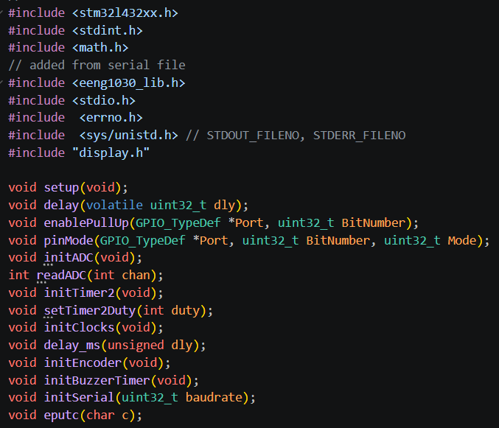
Figure 2: Declaration of functions and addition of necessary files and libraries.

Figure 2 above shows a hardware initialization and utility library for an STM32L432xx microcontroller (ARM Cortex-M4). It provides core functions for peripheral control, timing, analog reading, PWM generation, encoder interfacing, buzzer control, and serial communication. The code appears to be part of a larger embedded systems project (likely for a robotics or mechatronics course, given the eeng1030_lib.h reference).

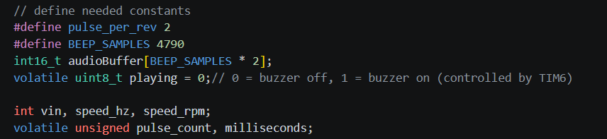
Figure 3: Declaration of global variables.

Figure 3 above shows the constants and variables for motor speed sensing and buzzer audio playback on an STM32 microcontroller. The constant pulse_per_rev is set to 2, meaning the motor encoder generates two pulses per revolution, while BEEP_SAMPLES defines the audio buffer size as 4790 samples. An int16_t array called audioBuffer allocates twice that many elements (9580 total) to store audio data for buzzer tones, and a volatile uint8_t flag named playing tracks whether the buzzer is active (1) or off (0), with updates controlled by Timer 6 interrupts. Integer variables vin, speed_hz, and speed_rpm hold motor voltage input and speed values in hertz and RPM respectively. Finally, two volatile unsigned variables—pulse_count for counting encoder pulses and milliseconds for system timing—are declared volatile because they are modified inside interrupt service routines but accessed in the main program loop.

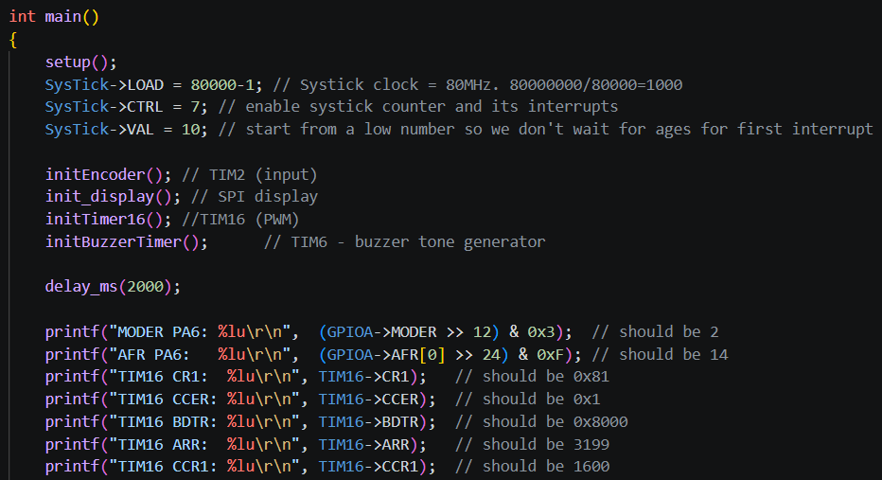
Figure 4: Main function of the software implementation part 1.

This main() function in Figure 4 above initializes the entire embedded system and then verifies the configuration by printing register values. It begins by calling setup() for basic hardware initialization, then configures the SysTick timer to generate interrupts every 1 millisecond (since an 80 MHz clock with a load value of 80,000 produces exactly 1000 Hz). It initializes the encoder on Timer 2, an SPI display, Timer 16 for PWM output, and Timer 6 for buzzer tone generation. After a 2-second delay to allow everything to stabilize, it prints the current register values for GPIO pin PA6 (checking its mode and alternate function), followed by several Timer 16 registers including CR1 (control), CCER (capture/compare enable), BDTR (break and dead-time), ARR (auto-reload value), and CCR1 (capture/compare value). These print statements serve as diagnostic checks to confirm that Timer 16 was configured correctly—for example, the ARR should be 3199 and CCR1 should be 1600, indicating a 50% duty cycle on the PWM output.

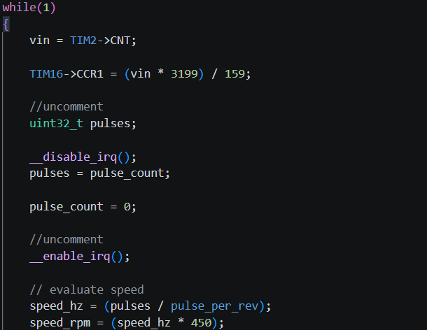
Figure 5: Main function of the software implementation part 2.

Figure 5 above shows continuous loop reads the motor's input voltage from Timer 2's counter register, scales it by a factor of 3199/159 (approximately 20.12) and writes the result to Timer 16's capture compare register to control a PWM output—likely for motor speed or LED brightness. It then safely copies the volatile pulse_count variable into a local pulses variable by disabling interrupts briefly to prevent corruption during the read, resets pulse_count to zero for the next measurement interval, and re-enables interrupts. Finally, it calculates the motor speed in hertz by dividing the accumulated pulses by pulse_per_rev (which is 2), then converts that to RPM by multiplying by 450—the conversion factor assumes the measurement period is 0.1333 seconds (since 60 seconds divided by 0.1333 equals 450). This loop continuously reads feedback, updates control outputs, and computes rotational speed in real time.

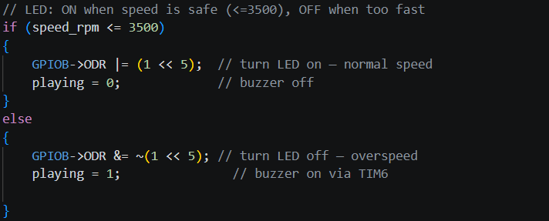
Figure 6: Main function of the software implementation part 3.

This code implemented in Figure 6 shows a safety monitoring system that controls an LED and buzzer based on motor speed. If speed_rpm is 3500 RPM or less (safe zone), it turns the LED on by setting bit 5 of GPIOB's output data register, and ensures the buzzer is off by setting playing = 0. If the speed exceeds 3500 RPM (overspeed condition), it turns the LED off by clearing bit 5, and activates the buzzer by setting playing = 1, which enables Timer 6 to generate an audible alarm tone. This provides both visual feedback (LED on/off) and audible warning (buzzer) to alert the user when the motor is running too fast.

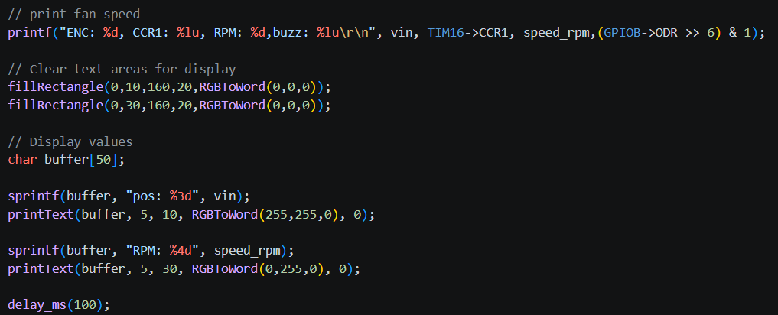
Figure 7: Main function of the software implementation part 4.

This code in Figure 7 handles real-time data output and user interface updates. It first prints a status line over serial containing the encoder value (vin), the current PWM capture compare register value from Timer 16, the calculated motor speed in RPM, and the buzzer state (extracted from bit 6 of GPIOB's output data register). It then updates an SPI display by clearing two text areas (at Y-positions 10 and 20, and 30 and 40) using black rectangles. The encoder position (vin) is formatted into a string labeled "pos" and displayed in yellow text at the top, while the RPM value is formatted and displayed in green text below. Finally, a 100 millisecond delay sets the loop's update rate to approximately 10 Hz, providing stable, readable updates without overwhelming the system.
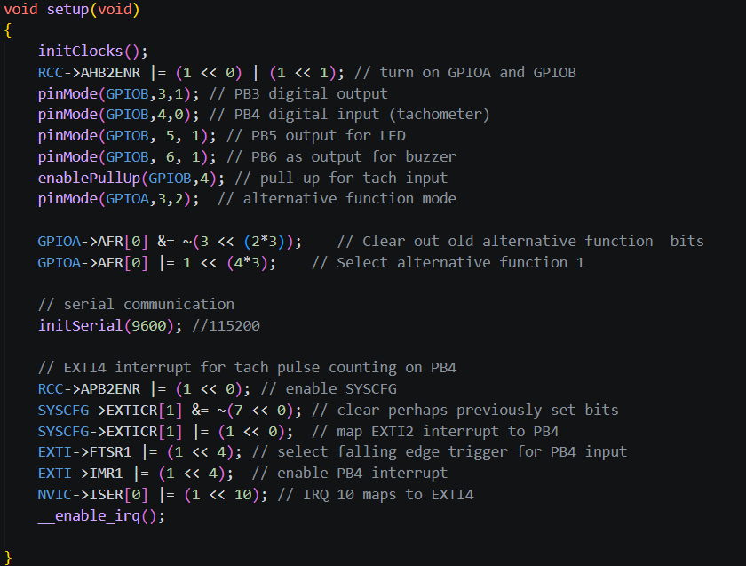
Figure 8: Setup Function.

This setup() function shown in Figure 8 above performs all low-level hardware initialization for the system. It starts by calling initClocks() to configure system clocks, then enables GPIO ports A and B via the AHB2ENR register. It configures several GPIO pins: PB3 as a digital output, PB4 as a digital input for tachometer sensing (with a pull-up enabled), PB5 as an output for the status LED, and PB6 as an output for the buzzer. Pin PA3 is set to alternative function mode, and its alternate function is configured to AF1 (likely for timer input capture). Serial communication is initialized at 9600 baud for debugging output. The function then sets up an external interrupt on PB4 to count tachometer pulses: it enables the SYSCFG clock, configures the EXTI to map PB4 to interrupt line 4, selects falling edge triggering, enables the interrupt in the EXTI controller, and enables the EXTI4 interrupt in the NVIC (IRQ 10). Finally, it globally enables interrupts with __enable_irq(), allowing the tachometer pulse counting to begin.
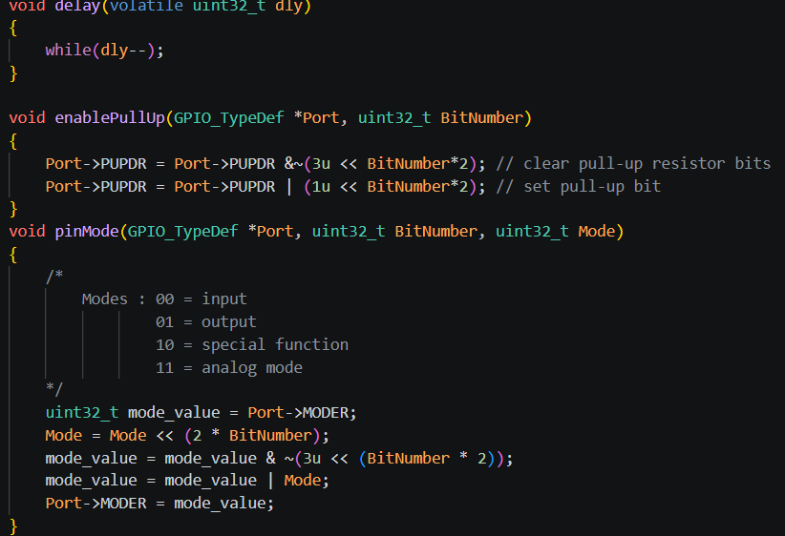
Figure 9: delay , Pull Up resistor and Pinmode.

These three functions shown in Figure 9 above provide basic GPIO control and timing utilities.
delay(volatile uint32_t dly) creates a simple blocking delay by decrementing the input value in a tight while loop until it reaches zero. The parameter is declared volatile to prevent the compiler from optimizing away the loop.
enablePullUp(GPIO_TypeDef *Port, uint32_t BitNumber) activates the internal pull-up resistor on a specified GPIO pin. It clears the two bits controlling the pull configuration for that pin by ANDing with a mask, then sets the lower bit (binary 01) to select pull-up mode.
pinMode(GPIO_TypeDef *Port, uint32_t BitNumber, uint32_t Mode) configures the mode of a GPIO pin by writing to the port's MODER register. The Mode parameter (0=input, 1=output, 2=alternate function, 3=analog) is shifted left by twice the bit number to align with the two bits that control that pin, then combined into the register after clearing the existing configuration bits for that pin.

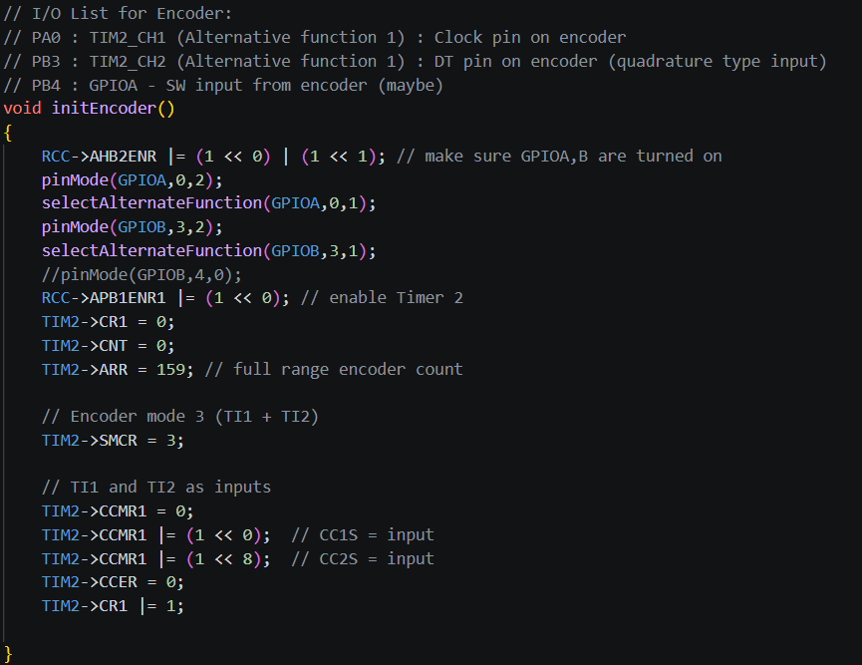
Figure 10: Timer 2.

This initEncoder() function configures Timer 2 shown in Figure 10 above in encoder mode to read a quadrature rotary encoder. It enables GPIOA and GPIOB clocks, then configures PA0 as TIM2 channel 1 (clock pin) and PB3 as TIM2 channel 2 (DT pin) both in alternate function mode with AF1 selected. Timer 2 is enabled, its counter is reset to zero, and the auto-reload register ARR is set to 159, which limits the count range from 0 to 159. The SMCR register is set to mode 3, which configures the timer to count on both TI1 and TI2 edges (quadrature decoding). The CCMR1 register sets both capture compare channels 1 and 2 as inputs, and CCER is cleared to configure the inputs. Finally, the timer is started by setting bit 0 in CR1. As the encoder rotates, the timer count automatically increments or decrements based on direction, and the value can be read from TIM2->CNT.
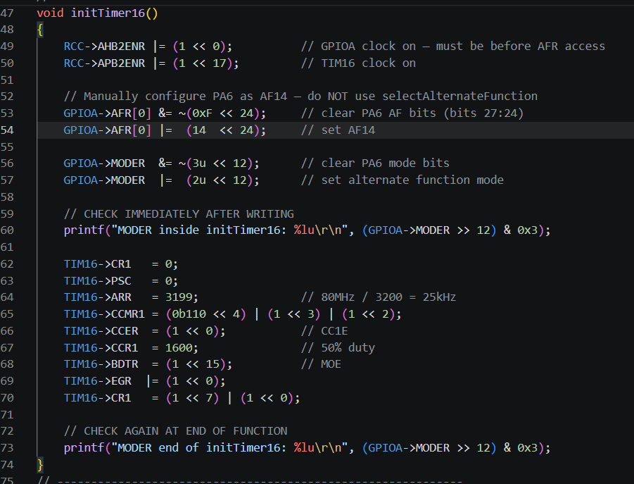
Figure 11: Timer 16.
This initTimer16() function shown in Figure 11 configures Timer 16 to generate a PWM signal on pin PA6. It enables the GPIOA clock and Timer 16 clock, then manually configures PA6 to use alternate function 14 (AF14), which is the timer output channel for TIM16. The pin mode is set to alternate function. Diagnostic printf statements verify the pin's mode register value immediately after configuration. The timer itself is then set up: prescaler is 0, the auto-reload register ARR is 3199, which with an 80 MHz clock produces a PWM frequency of 25 kHz. The CCMR1 register configures channel 1 for PWM mode 2 (110 binary) with preload enabled, and CCER enables the capture/compare output. CCR1 is set to 1600, giving a 50% duty cycle. The BDTR register's MOE (Main Output Enable) bit is set, which is required for advanced timers to enable PWM output. An update event generates reloads the settings, and CR1 enables auto-reload preload and starts the timer counter.

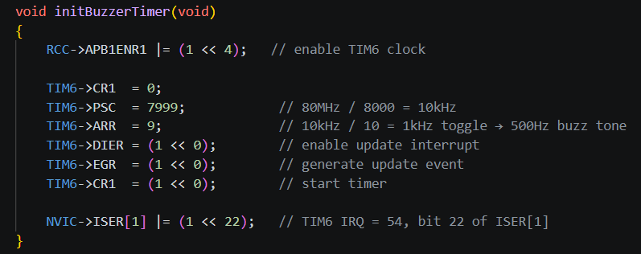
Figure 12: Timer 6.

This initBuzzerTimer() function shown in Figure 12 above configures Timer 6 to generate an interrupt for producing an audible buzzer tone. It enables the TIM6 clock via the APB1ENR1 register, then sets the prescaler to 7999, which divides the 80 MHz system clock down to 10 kHz. The auto-reload register ARR is set to 9, meaning the timer counts from 0 to 9 and then resets, creating an update event at 1 kHz (since 10 kHz divided by 10 equals 1000 Hz). This triggers an interrupt twice per cycle, allowing the buzzer pin to toggle at 500 Hz, which produces an audible 500 Hz tone. The DIER register enables the update interrupt, an update event is generated to load the prescaler and ARR values, and the timer is started by setting bit 0 in CR1. Finally, the interrupt is enabled in the NVIC at IRQ number 54 (bit 22 in ISER[1]), allowing the buzzer control to be handled in the TIM6 interrupt service routine.

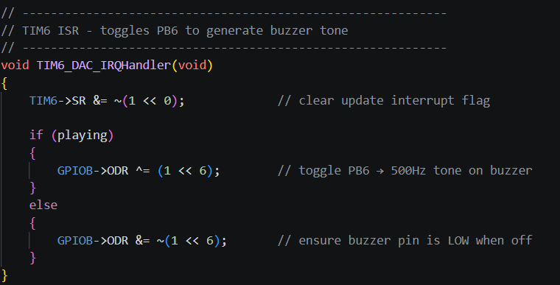
Figure 13: Timer 6 interrupt .

This is the interrupt service routine for Timer 6 shown in Figure 13 which generates the buzzer tone. When a timer update interrupt occurs, the handler first clears the interrupt flag by writing 0 to bit 0 of TIM6's status register (SR). It then checks the global playing flag: if playing is 1 (buzzer active), it toggles pin PB6 by XORing bit 6 of GPIOB's output data register, creating a square wave at 500 Hz and producing an audible tone. If playing is 0 (buzzer off), it ensures the buzzer pin is driven low by clearing bit 6, keeping the buzzer silent. This ISR runs at 1000 Hz (every 1 ms), toggling the pin on each interrupt to produce the 500 Hz tone only when the overspeed condition is active.

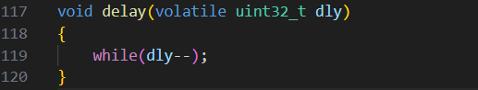
Figure 14: Function of installing delay.

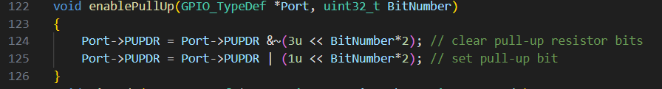
Figure 15: Function to enable pull-up resistor.
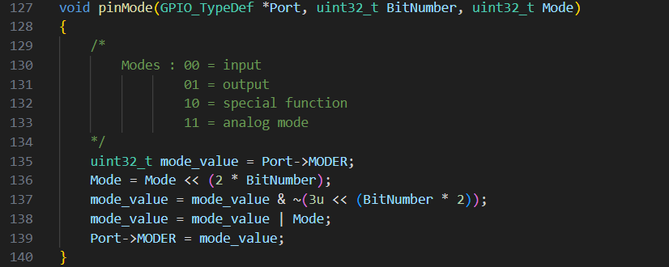
Figure 16: Function for PIN mode selection.

.

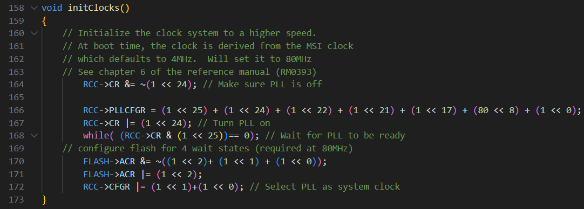
Figure 17: Function for initializing clock.

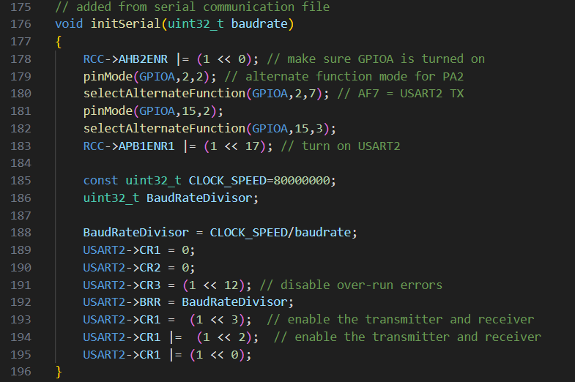
Figure 18: Function of initializing serial communication and pin definition.

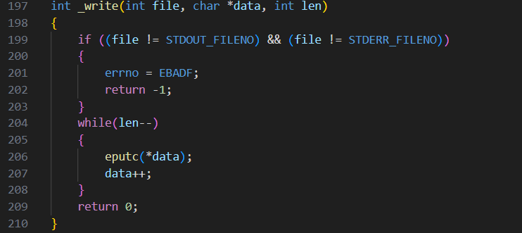
Figure 19: Function for writing via serial communication.

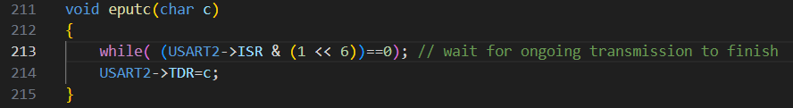
Figure 20: Function for write via serial communication to terminal display.

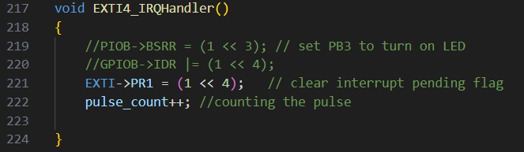
Figure 21: Function to handle interrupt to counting the speed pulse.

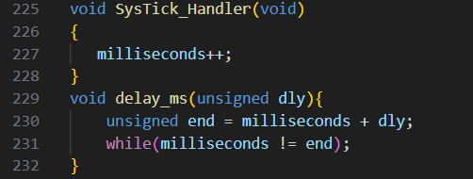
Figure 22: Function for milliseconds counting and delays.

Testing:

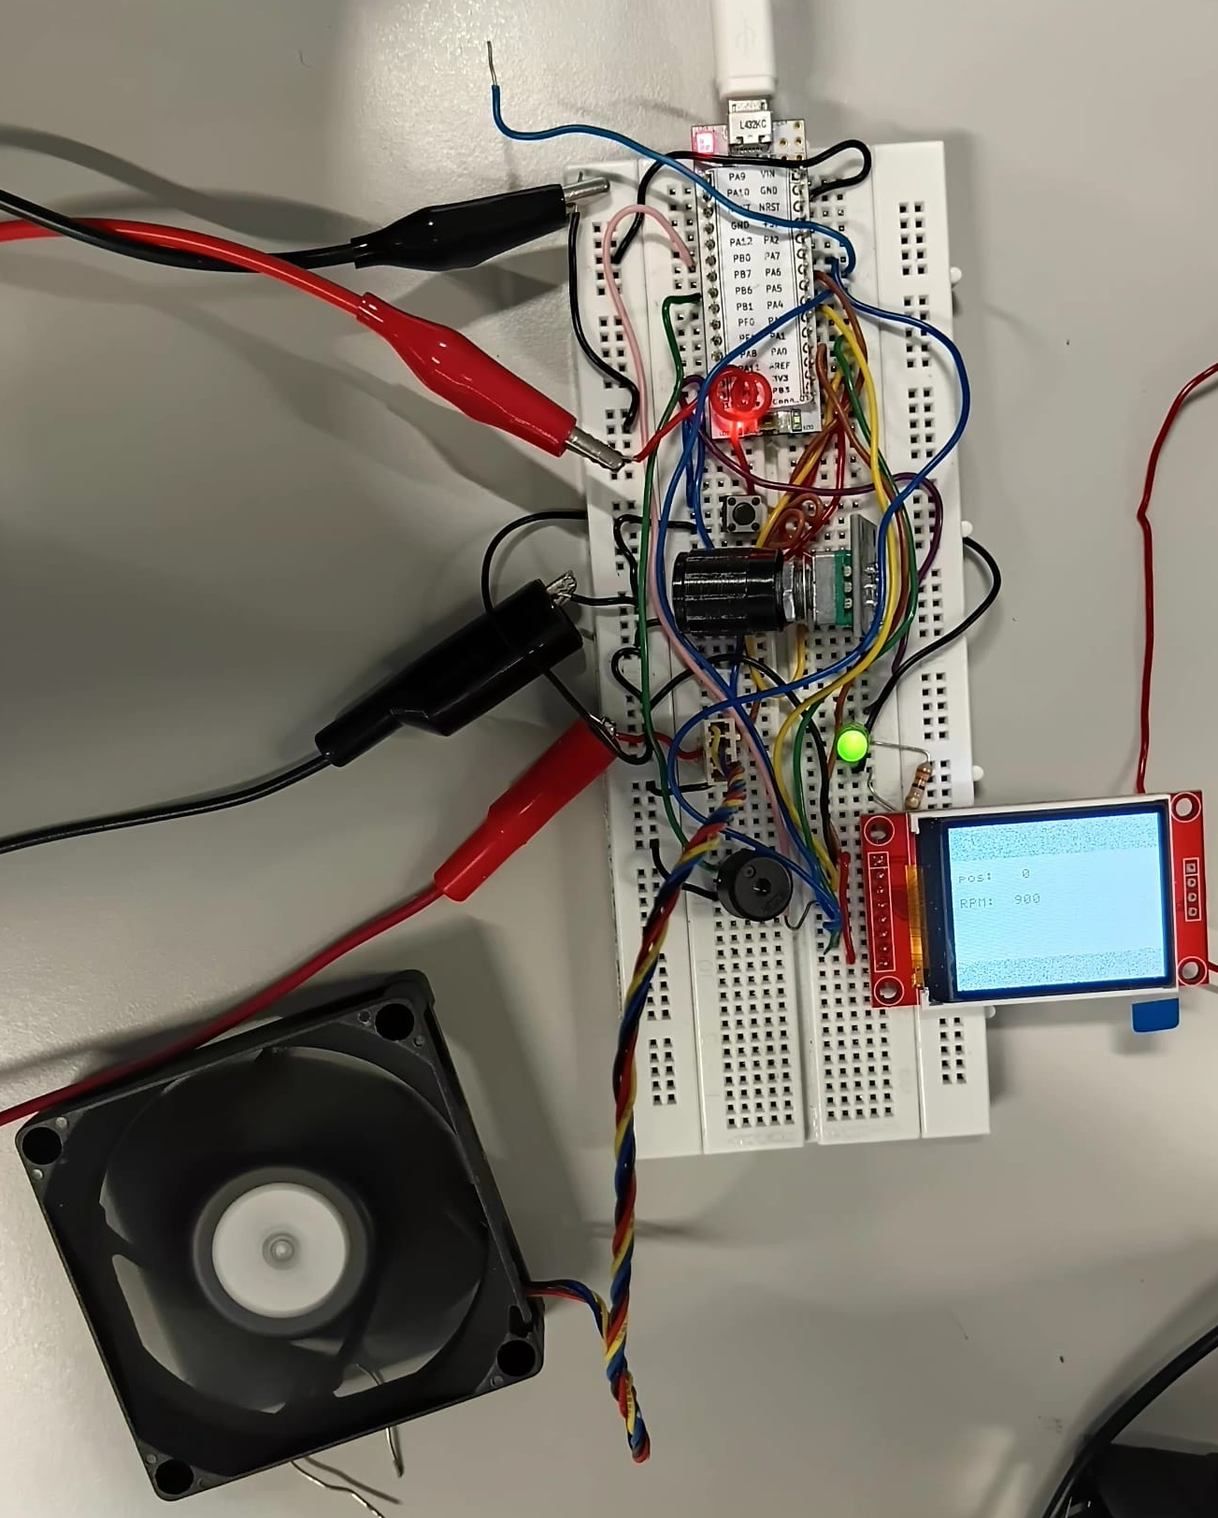

Figure 23: Hardware implementation of bread board.

The whole assemble is shown above in Figure 23 where the PC fan controller is being power,programmed and debugged.

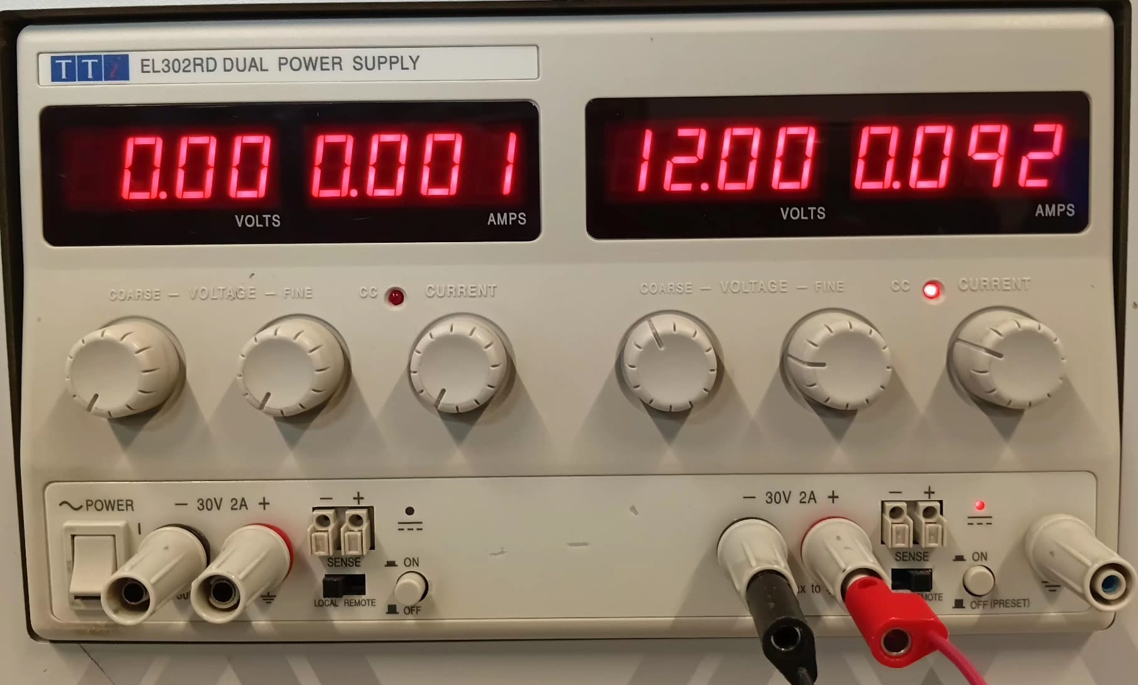
Figure 24: Power supply.

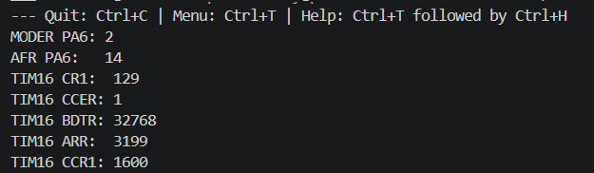
Figure 25: Output result 1 on terminal.

The printed diagnostic values shown in Figure 25 confirm that Timer 16 and its associated GPIO pin PA6 have been configured correctly for PWM output. PA6's mode register reads 2, indicating alternate function mode, and its alternate function register reads 14, which correctly maps to TIM16 channel 1. Timer 16's control register CR1 shows 129 (binary 10000001), meaning the counter is enabled with auto-reload preload activated. The capture/compare enable register CCER reads 1, confirming the output channel is enabled, while the break and dead-time register BDTR reads 32768 (binary 1000000000000000), indicating the main output enable bit is set—a critical requirement for PWM output on advanced timers. Finally, the auto-reload register ARR contains 3199, producing a 25 kHz PWM signal from the 80 MHz clock, and the capture/compare register CCR1 contains 1600, giving a precise 50% duty cycle. All values match the expected configuration, confirming TIM16 is fully operational and ready to generate PWM signals on pin PA6.

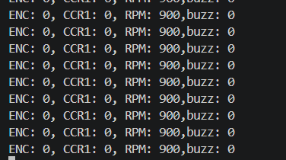
Figure 26: Output result 2 on terminal.

The result in Figure 26 shows the speed of max of 900 revolution per minute when the potentiometer is at minimum level.

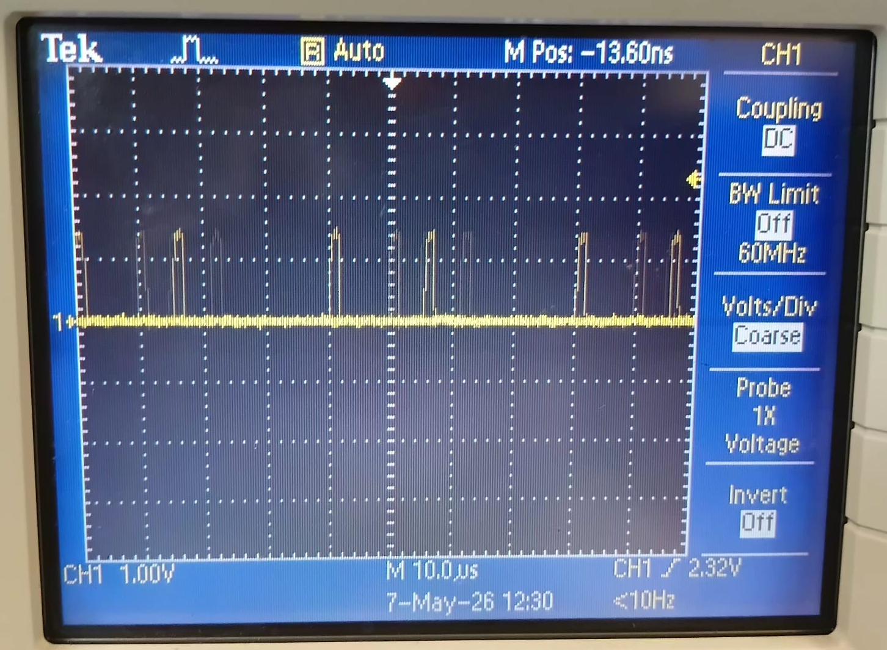
Figure 27: Fan output speed signal 1 viewed on oscilloscope.

The Figure 27 shows the duty cycle at 900 RPM which is almost 0% duty cycle.
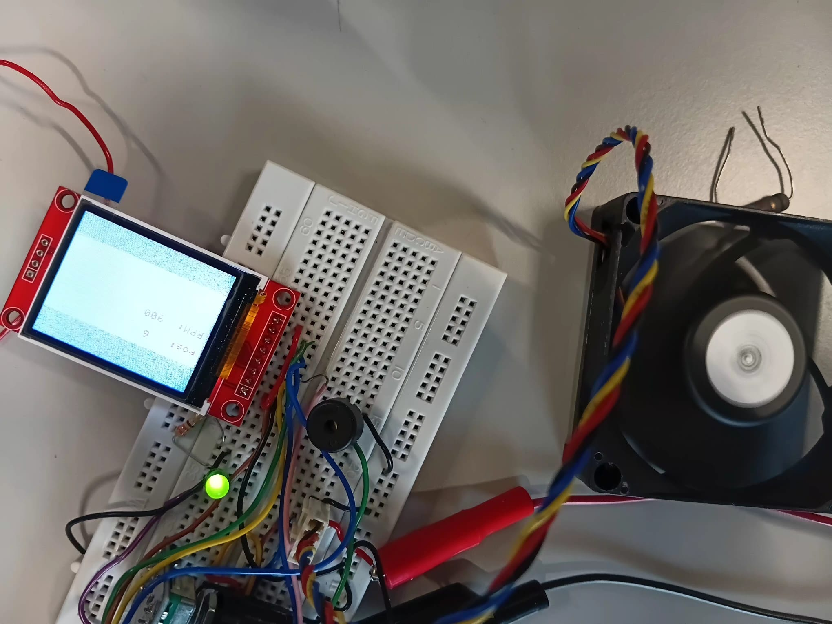
Figure 28: PC fan Assemble with LED ON and Screen .

The result in Figure 28 shows the output speed signal from the PC fan with LED ON, Fan ON and Screen indicating rotary position: 6 and speed 900 RPM.

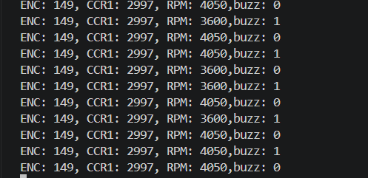

Figure 29: Output result 2 on terminal.

The result in Figure 29 shows rotary postion:149 with speed minimum of 3600 and buzzer toggling between 0 and 1.

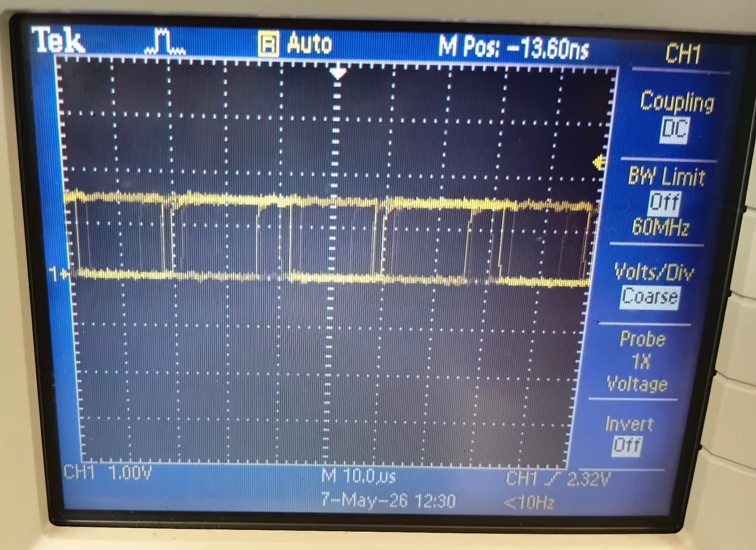
Figure 30: Fan output speed signal 2 viewed on oscilloscope.

The Figure 30 shows the duty cycle at minimum 3600 RPM which is almost 100% duty cycle.

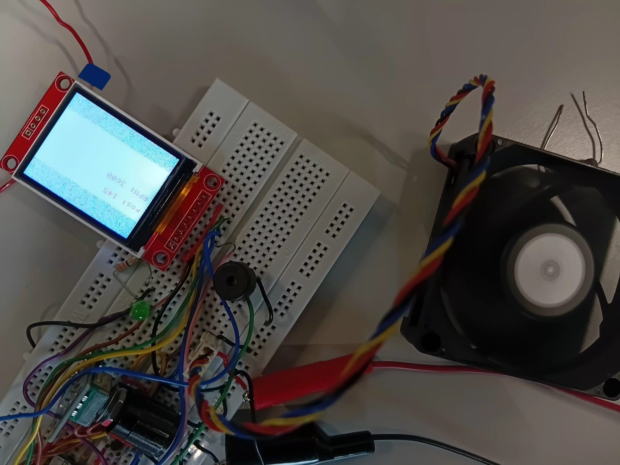
Figure 31: PC fan Assemble with LED OFF, Buzzer toggling and Screen .

The result in Figure 31 shows the output speed signal from the PC fan with LED OFF, Fan ON and at maximum and Screen indicating rotary position: 145 and speed 3600 RPM.

Conclusion:

The Advanced PC Fan Speed Controller using the STM32L432KC microcontroller was successfully designed, implemented, and tested. The project achieved all objectives, including schematic design, software and hardware implementation, testing, debugging, and documentation. The system effectively controlled fan speed through PWM generation, monitored RPM using tachometer feedback, and provided real-time user interaction through the LCD display and serial communication. Safety features such as LED indication and buzzer alerts operated correctly during over speed conditions. Experimental results confirmed accurate PWM control, reliable speed measurement, and stable system performance, demonstrating the effectiveness of the STM32-based embedded control system for PC fan applications.

References:
[1] STMicroelectronics STM32L432KC Datasheet, “STM32L432KC Datasheet,” STMicroelectronics, Geneva, Switzerland, 2023. Accessed: May 8, 2026.
[2] STM32L4 Series Reference Manual RM0394, “STM32L4x1 Advanced ARM®-based 32-bit MCUs Reference Manual,” STMicroelectronics, Geneva, Switzerland, 2023. Accessed: May 8, 2026.
[3] Omron Tactile Switches, “Tactile Switch Specifications,” Omron Electronics, Kyoto, Japan. Accessed: May 8, 2026.
[4] Kingbright LED Products, “LED Component Datasheets,” Kingbright Electronic Co., Taipei, Taiwan. Accessed: May 8, 2026.
[5] Vishay Resistors, “Resistor Products and Specifications,” Vishay Intertechnology, Malvern, PA, USA. Accessed: May 8, 2026.
[6] Bourns Rotary Encoders, “Incremental Rotary Encoder Datasheets,” Bourns Inc., Riverside, CA, USA. Accessed: May 8, 2026.
[7] ST7735 TFT LCD Controller Datasheet, “ST7735 TFT LCD Controller/Driver Datasheet,” Sitronix Technology Corp., Hsinchu, Taiwan. Accessed: May 8, 2026.
[8] Murata Piezoelectric Sound Components, “Piezoelectric Sound Components,” Murata Manufacturing Co., Kyoto, Japan. Accessed: May 8, 2026.
[9] Intel 4-Wire PWM Controlled Fan Specification, “4-Wire Pulse Width Modulation (PWM) Controlled Fans Specification,” Intel Corporation, Santa Clara, CA, USA, Sep. 2005. Accessed: May 8, 2026.
[10] STMicroelectronics USART Application Note, “USART Communication Application Note,” STMicroelectronics, Geneva, Switzerland. Accessed: May 8, 2026.
[11] SparkFun Breadboard Tutorial, “How to Use a Breadboard,” SparkFun Electronics, Boulder, CO, USA. Accessed: May 8, 2026.
[12] Pololu Jumper Wires, “Jumper Wire Specifications,” Pololu Corporation, Las Vegas, NV, USA. Accessed: May 8, 2026.
[13] Keysight Bench Power Supply Basics, “Fundamentals of DC Power Supplies,” Keysight Technologies, Santa Rosa, CA, USA. Accessed: May 8, 2026.

